RAJENDER KETHIPALLI HW3 MAVEN INSTALLATION

BINARY UPDATION

APT –GET UPDATE

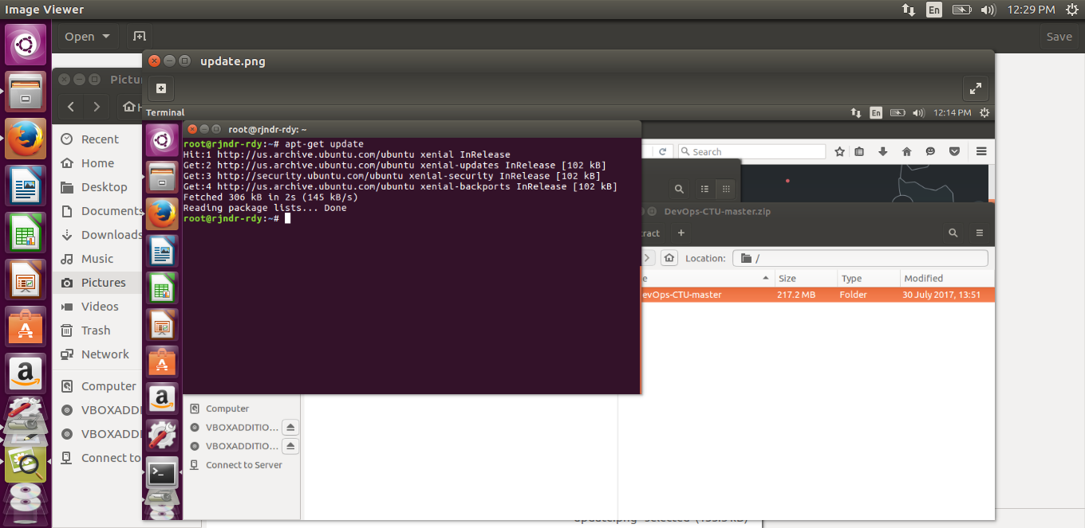

APT –GET INSTALL MAVEN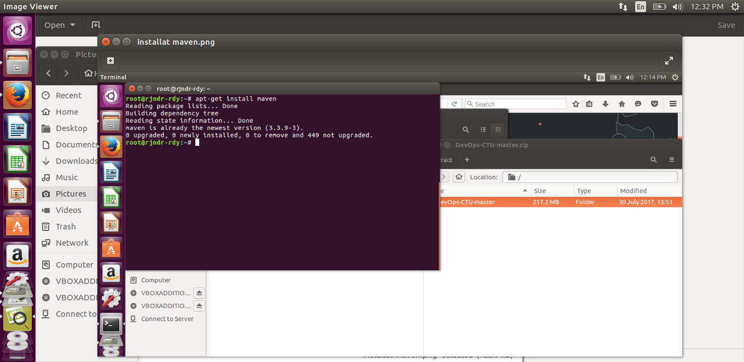

MVN –VERSION

